CSCE866 Software Design Methodologies

Assignment 4

Team: JOYY
Team Members:

Yi Chen

Yuhui Jiao
John Erickson
Date: 04-25-02
1.

A. Activity diagram

The activity diagram can model workflow of the business process. The customer sends RFQ to contractor. If there are questions, the contractor sends the questions and options to the customer. The parties conduct negotiations regarding the questions[s]. The Customer may send Addendums to the contractor. That means the parties make an agreement. The contractor next conducts two activities: 1. Calculate the labor cost. 2. Send RFQs to suppliers. There are two types of suppliers: vendors and subcontractors. They return material and/or labor costs in response to the contractor’s RFQ. The supplier will return a quotation to contractor. The Contractor collects the labor costs from the suppliers.
The contractor calculates the total cost for the RFQ and, sends the final quotation to the customer.
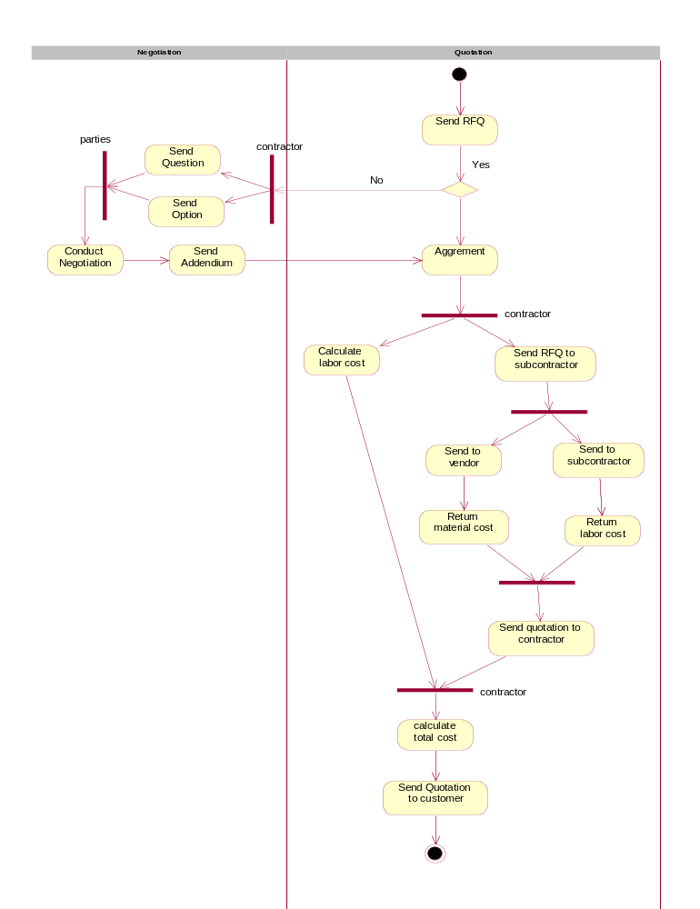
B. Sequence Diagrams and Interaction Diagrams

There are two phases in this model: negotiation and quotation. In the negotiation phase, the parties need to agree with each other about the options. After that, the parties will be in agreement. Sequence diagram 2 shows the sequence of activities in the negotiation phase. The Customer sends an RFQ to the contractor. The Contractor analyzes the RFQ and sends any questions to the customer. The customer is responsible for answering the questions. Then the customer sends an addendum to contractor for any changes made. In order to complete the quotation for the project, contractor needs to collect price information from the vendors and subcontractors. This process includes the following steps: The customer sends an RFQ to the supplier, who may ask questions, send addendums, and reach agreement. Sequence diagram 3 shows the steps in the quotation phase. The vendor and subcontractor return their quotation to the contractor. The contractor calculates the labor costs and quotations from suppliers. The contractor generates the quotation, and sends the final version to the customer.
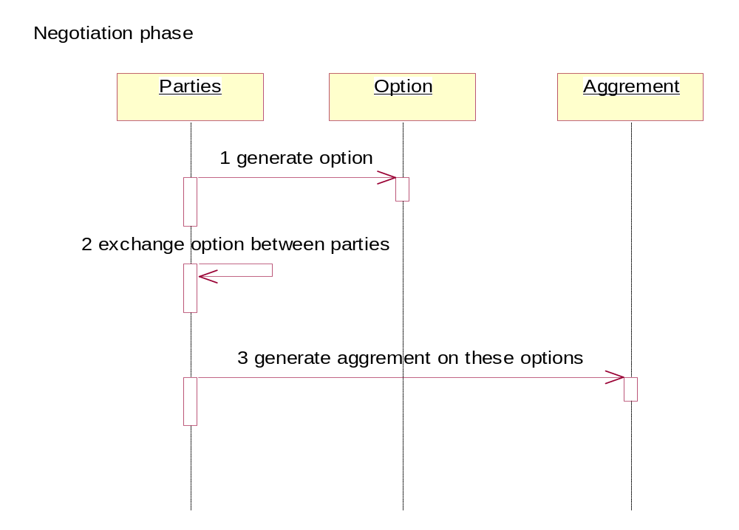
Sequence Diagram 1
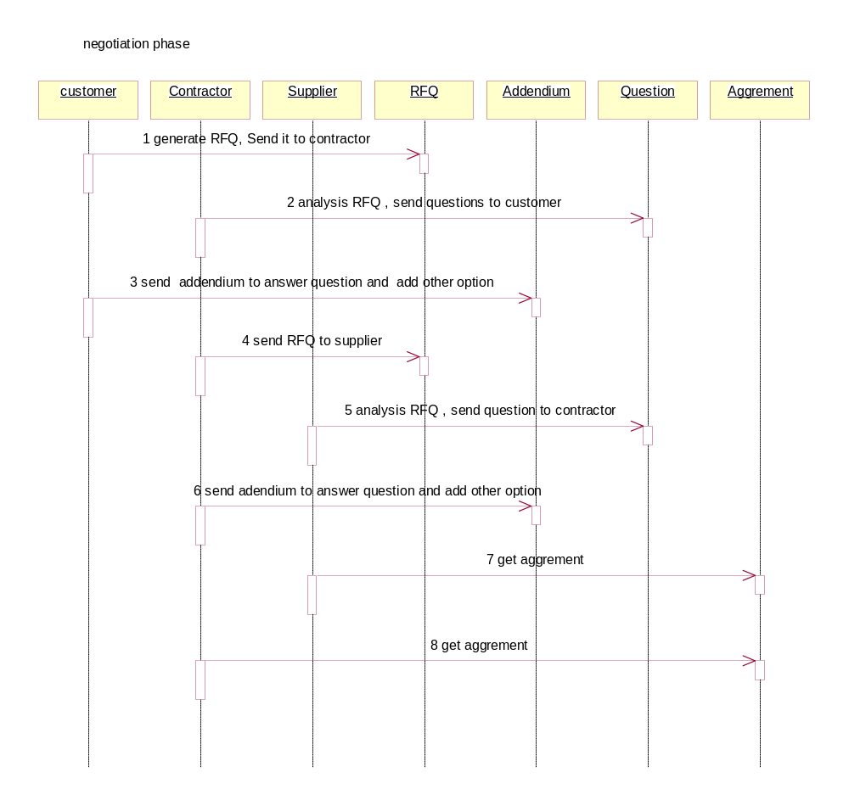
Sequence Diagram 2
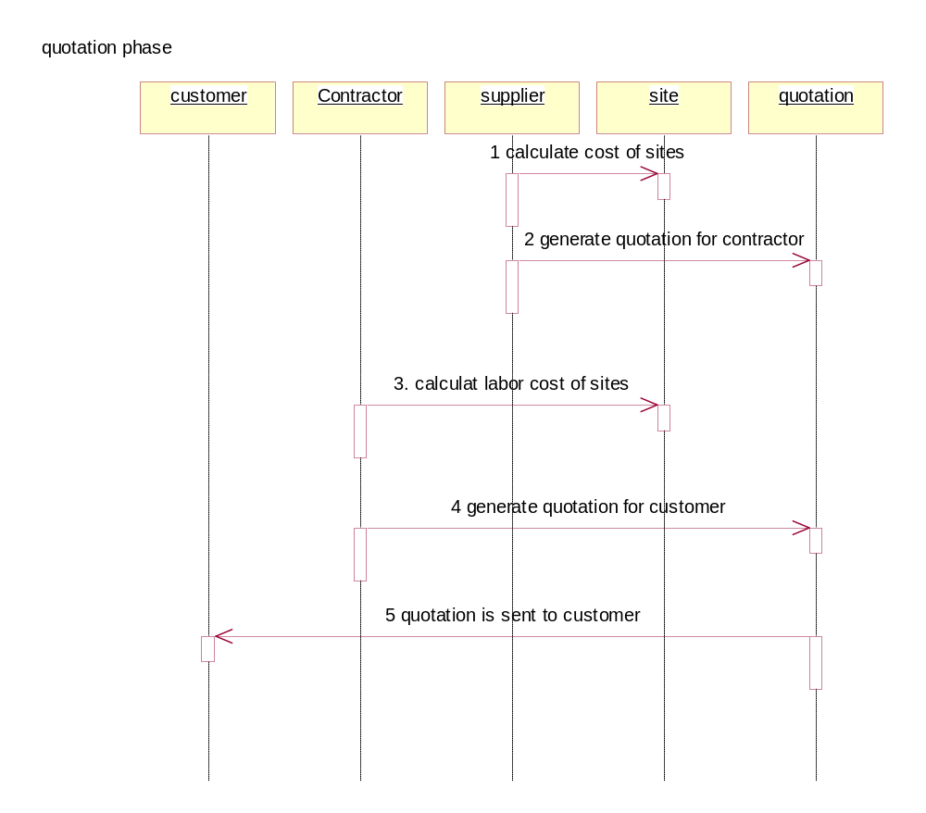
Sequence Diagram 3

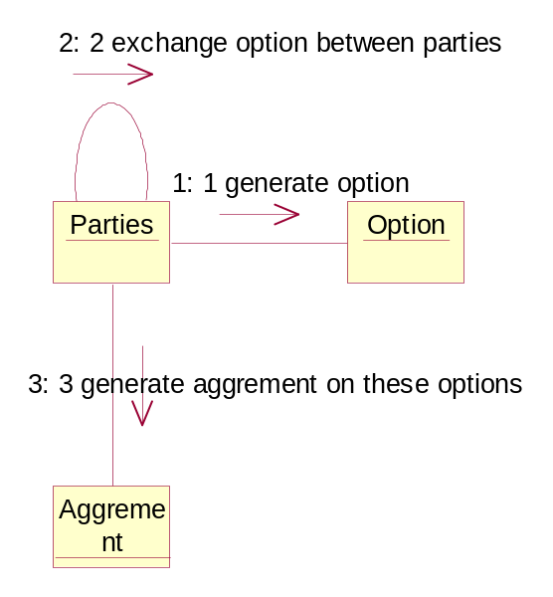
Collaboration Diagram 1 [Isomorphic to Sequence Diagram 1]
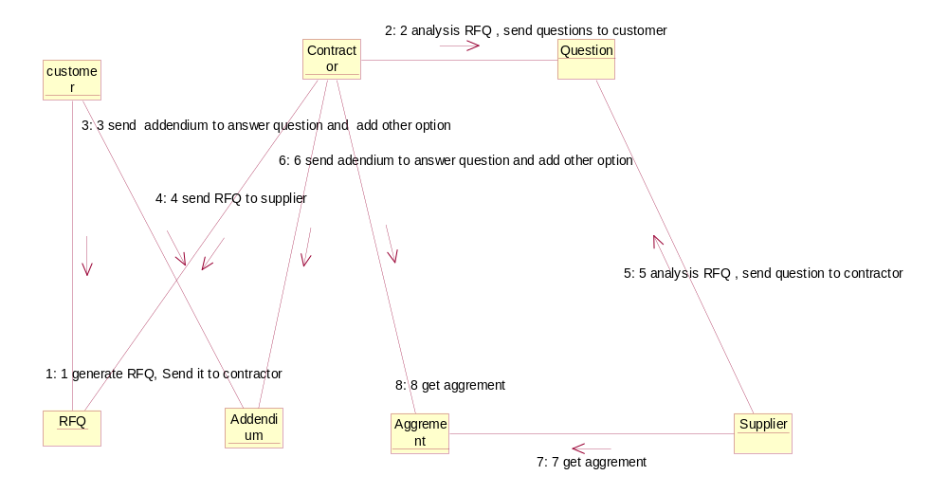
Collaboration Diagram 2 [Isomorphic to Sequence Diagram 2]

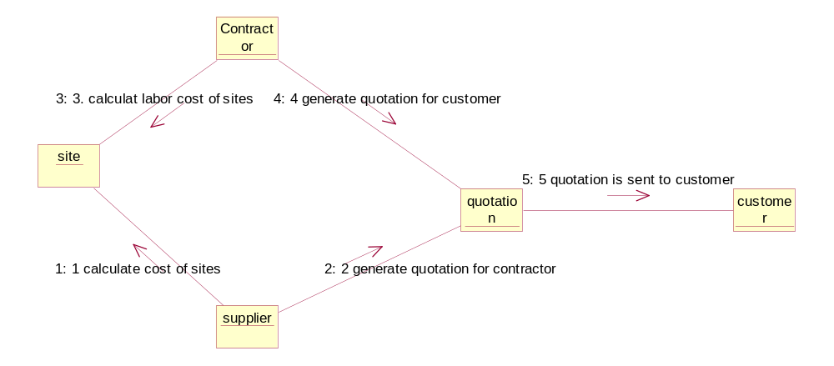
Collaboration Diagram 3 [Isomorphic to Sequence Diagram 3]
- State Transition Diagrams

STD 1 shows the system during a series of events in which a customer logs on to issue an RFQ or addendum.
Start
Ready to Logout
Click Logout Button
Ready to Issue RFQ/Addendum
Click RFQ Button
Input RFQ Form
Ready to Register
Click Register Button
Input Information
Ready to Logout
Click Logout Button
Ready to Login
Input Custmer ID and password
Customer Idle
Customer Active
RFQ/Addendum Ready
Stop
STD 2 indicates the status of the RFQ and Addendum processes.
Ready for close RFQ
Choose the best quota
Send quotation to customer

Ready for bidding
Break RFQ into SiteLine
Addendum Needed
Complete Addendum Form
Submit Addendum
RFQ Form Completed
Click Submit Button
Start
RFQ Idle
Stop
RFQ Ready
Customer ready to cancel
Click Cancel Button
Addendum Established
Customer ready to cancel
Click Cancel Button
Bidding Started
Ready for bidding
Break RFQ into SiteLine
STD 3 shows the events and conditions that occur when an RFQ has been received, and a [blank] Quotation related to the RFQ created in the system.
STD 3
Quotation Ready to close
Choose the best quotation
Form the final quotation form
Send the quotation to customer

RFQ ready for bidding
RFQ Sitelines listed
Contractor bid on siteline

RFQ/Addendum Ready
Submit RFQ

Stop
Start
Quotation Idle
RFQ Activated
Quotation Bidding
STD 4 shows the contractor engaged in negotiations and compiling the RFQ.
Ready to logout
Click logout button

Subcontractor’s quotation Complete
Form the final quotation
Return quotation to custmoer
Service/Parts not available
Sent request to Subcontractor
Ready to Logout
Click logout button
Ready to Login
Enter ID and Password
Stop
Start
Contractor Idle
Contractor Active
RFQ Ready
Ready to Bid
Bid on the siteline
Negotiation
STD 5 shows the events that occur relative to a siteline at a given site in the RFQ.
Bidding closed
Best bidding is choosen
Form final quotation form

RFQ Submitted
Break RFQ into sitelines
SiteLine Idle
SiteLine Active
Bidding
Ready to bid
Contractor bid on siteline item
Start
Stop

STD 6 indicates the various parties involved in conducting transactions during the bidding process.
Parties ready to logout
Click logout button
Stop
Start
Parties ready
Enter login ID and password
Party Idle
Party Active
Transactioning
Party ready
Party perform its role in RFQ formation and bidding
2. Meta-models
- Activity Diagram – an activity diagram models some of the dynamic aspects of a system, it is essentially a behavioral model. An Activity diagram can be linked to classes, operations or uses cases. For the purposes of this assignment, the activity diagrams will model classes, and their attributes and operations. Other elements of activity diagrams include:
  - Starting point, representing where the activities in the diagram begin.
  - Activities, representing processes that have some duration.
  - Flow arrows, representing the flow of control as the activities are carried out.
  - Decision diamonds, representing where [unsynchronized] branching may occur.
  - Synchronization bars, representing parallel flows, where in general [there can be exceptions to this] all of the parallel flows must be completed before subsequent activities can ensue. There are two types of synchronization bars:
    - Forks, representing parallel branches in the flow of control.
    - Joins, representing the joining of parallel flows.
  - Swim lanes, representing activities occurring in other [but related] responsibility domains.
  - End points, representing the terminus of activities in the diagram.

Activity Diagram Meta-model
Starting Point
Class
Activity Diagram
Fork
Decision Diamond
Flow Arrow
End Point
Join
Swim Lane
Operation
Attribute
Duration
1
1
1
1
1
1
1..*
1
1
1..*
1
1
*
Related To
Related To
Represented By
*
*
Has
1
Has
Activity
*
1
Has
- Collaboration Diagram – a sequence diagram is a type of Interaction diagram. Collaboration diagrams not only show classes and the relationships between those classes, but also emphasize the structural organization that exists between the classes. Collaboration diagrams are semantically equivalent to Sequence diagrams, in that one can be converted to the other without loss of information. Paths and Sequence number primarily distinguish collaboration diagrams from sequence diagrams. Collaboration diagrams include the following:
  - Classes
    - Attributes
    - Operations
  - Links
  - Messages
  - Notes
  - Constraints
  - Paths
  - Sequence numbers
Path
Message
Collaboration Diagram
Note
Constraint
Sequence Number
Link
*
*
1
*
*
*
May Relate To
*
Attribute
Operation
*
1
*
*
1
*
*
*
*
1
1
1
Has
May Relate To
May Have
May Depict Elements Of
Has
May Have
May Have
May Have
May Relate To
Class
Has
*
*
*

- Sequence Diagram – a Sequence Diagram is a type of Interaction diagram. Interaction diagrams show classes, and the relationship between those classes, including messages that may be passed among [or between] them. Sequence diagrams are behavioral diagrams, which model dynamic aspects of the system. Sequence diagrams also indicate the time ordering of messages, the length of time an object ‘lives’, and the focus of control as messages are sent and received. Items included in sequence diagrams include:
  - Classes
    - Attributes
    - Operations
  - Links
  - Messages
  - Notes
  - Constraints
  - Lifelines
  - Focus of Control

Sequence Diagram Meta-model
Lifeline
Message
Sequence Diagram
Note
Constraint
Focus of Control
Link
*
*
1
*
*
*
May Relate To
*
Attribute
Operation
*
1
*
*
1
*
*
*
*
1
1
1
Has
May Relate To
May Have
May Depict Elements Of
Has
May Have
May Have
May Have
May Relate To
Class
Has
*
*

- State Transition Diagram – a state transition diagram [STD] models system behaviors. However, in contrast to interaction diagrams, STDs usually model a series of related events [something that happens at a point in time – no duration]. Usually a STD models the transition of one or more of an object’s attributes from one state to another. The flow of such events is also part of STD modeling. Certain conditions will trigger the transition from one state to another. STDs will have an initial transition [from a starting point] and a final transition [to a stopping point].
  - Initial transition [starting point]
  - Actions [or activities]
  - States
  - Transitions
  - Conditions
  - Flow indicators [temporal orientation and/or sequencing – includes direction of flow]
  - Final transition [stopping point]
  - Classes
    - Attributes
    - Operations
Initial Transition
Class
Final Transition
Transition
Attribute
Operation
*
1
Has
State
Condition
Action
Flow Indicator
Indicates Flow Direction Between States
Indicates Flow Direction of Transitions
*
*
*
1
*
1
*
*
*
1
*
*
1
*
Related To
Related To
Represents
Triggers
Triggers

Has
1
*
3. Value of Design Heuristics

Heuristic 2.8 [“A class should capture only one key abstraction] seems valuable here because if the classes we have developed tried to do ‘too much’ it would become apparent when we start to use models other than simply class and use case diagrams to capture the behavioral aspects of the proposed system.

Heuristic 3.2 [The Macho class warning] seems especially relevant to this part of the systems analysis and design process. If we had created a macho class, modeling its behavior would have been very problematic. How would we be able to capture all of the functionalities of a macho class in a state transition or interaction diagram? What we would have done would probably not have been very easily accomplished or accurate.

Heuristic 3.6 [Model the real world]. This project is a good example of a real world system, and the models we have created have benefited from approaching the analysis and design from that perspective. Unless an analysis and design project has some inherent research or other value, then what good is it to create models not based on the real world?

Heuristic 4.3 [Minimize collaborations between classes and collaborators]. This makes a lot of sense because if we create collaborations simply because we can, the finished system will not be as good. Minimizing the number of collaborations forces designers to focus on what the core functionalities should be, and should result in a more efficient system.

4. Re-Written Problem Statement

Abstract
The problem is essentially one of developing a bidding/estimation system for a small subcontractor in the telecommunications infrastructure industry. Currently all quotations, estimation and negotiations are done by hand and with spreadsheets, and nothing in the process is automated. A bidding and estimation system would improve the response time and accuracy of the process.

Problem Domain Description
The system is a quotations management system for a small, second-tier subcontractor in the telecommunications industry. The company has been in business for approximately 30 years, serving such customers as AT&T, Rockwell International [now Alcatel Network Systems], Sprint PCS, Lincoln Telephone [now AllTel], and similar companies, as well as other contractors and material vendors in the telecommunications infrastructure industry. The company currently tracks all quotations and jobs [successful quotations] in an Excel spreadsheet, and an Access database, so multiple data entry [and related accuracy] is an issue here. A copy of one spreadsheet bid [RFQ] response, as still in use by the company is included in the appendix.

The customer sends RFQs [Requests For Quotation] to a group of their preferred vendors, who each estimate material and labor costs, based on the requirements specified in the quotation. The customer will select the bidder [contractor] who mostly closely matches their requirements, and usually, this means the contractor who responds with the lowest total price. A copy of an actual RFQ is included in the appendix. The RFQ may need to be modified because of incompleteness, because of questions the contractor asks, or additions/deletions the customer wishes to make to the scope of work in the RFQ. This means that the customer and the contractor must negotiate with each other on the RFQ, questions and addendum. Agreements may be reached on negotiations if all parties to the negotiations settle on the terms.

Each RFQ is an aggregation of jobsites [locations where the actual work is to be performed]. So, a given quotation will consist of at least one jobsite, but can easily include 10 or 30 or more sites. Larger contractors might be sent RFQs including hundreds or more jobsites.
Each jobsite can be seen as an aggregation of line items specific to that site. For example, AllTel’s cell site at 27th and Old Cheney Road might be a jobsite [the company actually built that cell cite a number of years ago]. At that site there is a list of items that the customer wants to be completed. For this system, we have called these line items sitelines, but that is just an arbitrary name.

The line items will normally be a material item, i.e. a DB212 antenna, with an associated labor line item that describes installation of the material items. In this way, the contractors can estimate the labor costs for installing the line items. The material [DB212 antenna], may be specified as either customer furnished or contractor furnished. If the customer furnishes an item, then the material line would naturally be blank or zero. If the contractor is to furnish the item, then the contractor must contact a vendor who supplies the specified material, for the cost of that material item. Some materials are bundled with labor, so the contractor will contact a subcontractor who may supply labor and material items for the main RFQ.

Contractor will send its own RFQ to the supplier [material vendor or subcontractor]. The supplier will respond with pricing for the item, including any necessary labor. Of course this process is not completed separately for each item, but rather a list of materials by jobsite, and line item is normally completed and sent to a number of different suppliers for pricing. The negotiation process described previously will apply to the contractor – supplier process relationships, and is conducted in a similar manner.

Problems that commonly occur with this process are that different contractors may interpret the RFQ differently. This causes problems in that the customer may be faced with a number of RFQ responses that are really not the same [the apples and oranges problem]. To alleviate this type of confusion, there is usually a formal addendum process involved with most large RFQs. An addendum can be issued at the request of the Customer, or any of the suppliers, in response to questions or clarifications thought necessary to the specifications. Addendums are issued before the RFQ due date, and contractors are expected to include responses to each addendum. A related but different problem that commonly occurs is that circumstances or requirements at a given jobsite might change after the contractor has been awarded the job. In this case that changes are normally handled by change orders. Change orders are not part of this system, although they would be part of a future order tracking system. All of the issues described in this paragraph as ‘problems’ may also be resolved through negotiation and agreement.

Occasionally, customers will request pricing for an item that has been discontinued or is ‘out of stock’ for the foreseeable future. Contractors then respond with pricing for alternate [equivalent] materials. Unless the customer can include this equivalent material in an addendum, they are likely to receive alternate pricing for several items, again leading to the apples and oranges problem.

If a contractor is the successful bidder on a given RFQ, then the customer will issue a contract for the project. Contracts usually specifically refer to or include the original RFQ as source documentation for the contract. For contractors, the successful bids/contracts become orders. Order tracking is not part of this system, but is a needed item for the future.
Glossary of terms

Addendum A change to the RFQ issued before the due date, and expected to be responded to by each contractor in their pricing response.
Agreement can be arrived at through negotiation on RFQ clarification questions, ambiguities and etc.
Change Order A change to the specifications after the contract has been signed.
Customer the company, organization or individual who sends RFQs to contractors. A company that has some sort of work they want someone else to do for a price.
Jobsite RFQs can be considered aggregations of Jobsites, in that each RFQ will consist of at least one jobsite. Jobsites are the specific locations where the products [material] or services [labor] are to be delivered.
Negotiation the process of communication between two or more parties regarding questions and clarifications. This turns out to be central to the system.
Order A successful RFQ response – results in a contract with the customer.
Quotation The contractor’s detailed and formal pricing response to an RFQ. Suppliers also quote material and labor pricing to the contractor.
RFQ Request For Quotation. A formal, usually written request, sent to a relatively small number of vendors who each respond with their best price for completing the work as specified in the RFQ.
Siteline Each jobsite can be considered as an aggregation of sitelines, or line items that specify in detail exactly what single product or service is to be provided. Jobsites will consist of at least one siteline.
Supplier a company [Vendor or Subcontractor] who provides a requested product or service to another company, organization or person for a given price.

Block Diagrams

Customer
Supplier
Contractor
Block diagram for quote process
RFQ
Query material price
Material price

Negotiation

Negotiation

Customer Interface
Interface for
supplier
Control part of
system
Material calculator
Labor calculator
Other cost calculator
Supplier database
Database for cost
Database for
Archieve

Information and
quotation
Order material
Query the cost
Block diagram for bidding system

